Built Environment

Call for Guest Editors:

Disability & the Built Environment

 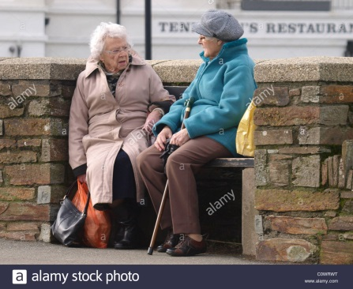 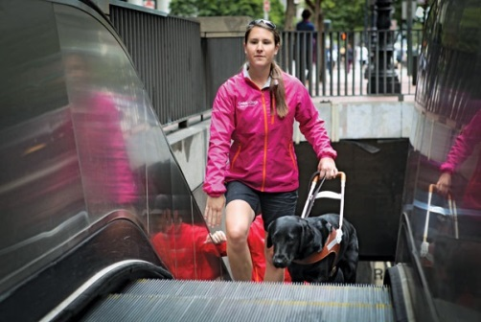

*Built Environment* invites proposals for a guest editor(s) to guest edit a themed issue of the journal on ‘Disability & the Built Environment’.

**Issue scope**

Prospective guest editors are invited to propose a specific thematic focus, for example:

* Enabling the Built Environment;
* Accessibility in the Built Environment;
* Urban Equity and Environmental Justice;
* Inclusive Design for a Diverse Population.

The issue is expected to address one or more aspects of disability, accessibility, equity and environmental justice in relation to the design and planning of the built environment, such as architecture, infrastructure, urban design, streetscape, public open spaces; addressing not only physical provision but social and decision-making aspects. The issue should lead the way for an international readership of built environment academics and practitioners.

**The journal**

*Built Environment* is an international peer-reviewed scholarly journal, published quarterly by Alexandrine Press: <http://alexandrinepress.co.uk/built-environment>

Each issue is a themed issue addressing some cutting-edge aspect of the built environment, typically addressing cross-disciplinary issues of interest to architects, landscape architects, urban designers, urban planners and urban policy-makers.

Issues range in length between 130 and 160 pages, with typically 8-12 papers of in the range 6000-12000 words. Papers should be accessibly written and appropriately illustrated.

Our companion blog, *Blogged Environment*, features shorter length articles linked to current and prospective issue themes: <http://alexandrinepress.co.uk/blogged-environment>.

**The guest editor role**

The core role of the guest editor is to:

* Define the scope and direction of the issue;
* Commission and edit papers by individual authors;
* Organise peer review, with assistance from the journal (editors/editorial board)

Additionally we encourage guest editors to:

* Arrange set of book reviews related to the issue topic;
* Contribute content to our blog, *Blogged Environment*. Meanwhile, we will also issue Twitter announcements via @blogged_env and we encourage contributors likewise to blog and tweet as part of the dissemination and promotion of the journal issue.

|  |
| --- |
| **This call: The Enabling Built Environment**  We invite short proposals to guest edit an issue on the above theme. In your proposal please indicate:   * proposed title of issue; * names of guest editors, with short biographies (200 words) * an outline of the scope and rationale of the issue (need, significance, timeliness of the theme, etc.); * a listing of proposed paper topics, including identified authors and 300-500 word abstracts; * a timescale, building in an iteration for peer review, assuming a target date for publication in late 2017 or early 2018.   Please submit your proposal in the first instance by Monday 5th December, by email to Prof Stephen Marshall, [s.marshall@ucl.ac.uk](mailto:s.marshall@ucl.ac.uk)  Earlier expressions of interest (before a formal proposal is constructed) are very welcome. For these and any other queries, please contact Stephen Marshall.  We expect to make a decision on this issue in December 2016. We do not guarantee that we will publish an issue on this theme, if there is no appropriate proposal received. |

***Built Environment*: further information**

Editors: Professor David Banister, University of Oxford; Professor Stephen Marshall, UCL; Reviews and Digital Content Editor: Dr Lucy Natarajan, University College London.

Previous themes of *Built Environment* include: [Big Data and the City](http://www.alexandrinepress.co.uk/built-environment/big-data-and-city) •[Suburban Spaces, Suburban Cultures](http://alexandrinepress.co.uk/built-environment/suburban-spaces-suburban-cultures) • [Tools for Equitable Urban Intensification](http://alexandrinepress.co.uk/built-environment/tools-equitable-urban-intensification) • [Marketplaces as an Urban Development Strategy](http://alexandrinepress.co.uk/built-environment/marketplaces-urban-development-strategy) • [Urban Violence](http://alexandrinepress.co.uk/built-environment/urban-violence) • [Co-Housing in the Making](http://alexandrinepress.co.uk/built-environment/co-housing-making) • [Informal Urbanism](http://alexandrinepress.co.uk/built-environment/informal-urbanism)

Issues make an attractive, identifiable physical product and may be purchased individually. All institutional subscriptions to *Built Environment* (ISSN 0263-7960) are print with free online. Subscribe at: <http://alexandrinepress.co.uk/built-environment/subscribe>

